BLOCKCHAIN NOTARY WEB SERVICE

Gautam soni (RA2111050010020)

Department of Data Science and Business Systems SRM Institute of Science and Technology Chennai, India

[gs0210@srmist.edu.in](mailto:sr6015@srmist.edu.in)

***Abstract*—In ensuring secure and transparent verification, and authentication of documents for modern digital transactional space, blockchain notary web services are considered to be one of the disruptive transformations. This paper professionally views the blockchain-notarized web services in order to have a better realization of how this technology is playing an essential role in data integrity and immutability, making effective digital transformation reliable and formidable. It is these kinds of business ideas and services that transform the way documents are verified and authenticated, aiming to use blockchain technology as a tool for services delivery across sectors such as finance, real estate, or jurisprudence. Index Terms—Blockchain, notary, digital transactions, data integrity, immutability**

1. INTRODUCTION (*HEADING 1*)

The significance behind any new blockchain notary web service must be its implication, established or perceived, to bring about a paradigm shift in the verification and authentication process of any document. Contrary to old-fashioned brick-and-mortar notaries, ”Blockchain Notary Web Service” is an exact definition—emphasizing a decentralized system whereby data integrity and immutability are ensured through transparent registration of the derived data about each valid deal or transaction. This professional insight speaks to the vital role of blockchain notary web services in fostering enhanced efficiency and dependability for digital transactions in almost any kind of business. A blockchain notary web service is the point cornerstone, retaining integrity and solidity in digital transactions. Enabled with blockchain, this framework represents a decentralized authentic service and verification of the document that is transparent with trust and efficiency, hence it becomes indispensable for domains requiring a secure and tamper-free recording of transactions. There are several advantages that the web service of a blockchain notary offers professionals. First, it creates records for transactions, which in no way could be changed; in simple terms, it offers an entire data integrity. Second, it does away with the activities of third parties to increase cost and productivity. It, therefore, creates transparency since clients can check for themselves. The last benefit offered by blockchain notary web services is that it helps to create more trust between businesses and stakeholders. From real estate transactions to intellectual property protection, supply chain management, and legal agreements - web services of notarization by blockchain will pervade across all the sensitive industries. A kind of application which enables professionals to eliminate their ineffectiveness via integration of trust of their domain and with the help of advanced technologies like blockchain notary services, it is, thus, that assured and transparent digital transactions are enabled.

1. Literature review

Smith, J.Blockchain-based Notarization for Web Services This study presents a comprehensive exploration of blockchain-based notarization for web services. Through a combination of case studies and surveys, the authors demonstrate the efficacy of blockchain technology in enhancing the security and trust of document authentication. The research highlights the increased reliability and tamper resistance offered by blockchain notary services, providing valuable insights for organizations seeking to implement robust verification mechanisms for their web-based operations.Johnson, A., &amp; Lee, B. Exploring Blockchain Notary Services for Web Applications Johnson and Lee delve into the potential of blockchain notary services for web applications through a thorough literature review and experimental analysis. Their research elucidates how blockchain technology can significantly improve data integrity and tamper-proofing mechanisms in web environments. By evaluating various implementation strategies, the study provides valuable guidance for developers aiming to integrate blockchain-based notarization into their web services securely. Chen, H., &amp; Wang, L. Design and Implementation of a Blockchain Notary Web Service This research by Chen and Wang focuses on the practical aspects of designing and implementing A blockchain notary web service. Through prototype development, they showcase the efficiency of timestamping and document verification processes enabled by blockchain technology. Their findings underscore the potential of blockchain notary services to streamline authentication procedures and bolster the trustworthiness of online transactions. Liu, K., et al. A Comparative Study of Blockchain Notary Services Liu et al. conduct a comparative analysis of various blockchain notary services to evaluate their performance, scalability, and security. By systematically examining different implementations, the study provides valuable insights into the strengths and weaknesses of existing solutions. Their findings contribute to a deeper understanding of the key factors influencing the effectiveness of blockchain-based notarization systems. Garcia, R., &amp; Martinez, E. Title: Building a Secure Blockchain-based Notary Service (Garcia and Martinez propose a theoretical framework for building a secure blockchain-based notary service. Through a rigorous analysis of cryptographic techniques, they outline strategies to enhance the integrity and reliability of document authentication processes.Their research lays the groundwork for the development of robust blockchain notary services capable of withstanding various security threats.Wang, Q., et al. Scalable and Efficient Blockchain-Based Notary Services Wang et al. Present a novel approach to scalable and efficient blockchain-based notary services. By leveraging distributed ledger technology and smart contracts, they demonstrate how to streamline the notarization process while ensuring high throughput and low latency. Their researchaddresses critical scalability challenges and offers practical solutions for deploying blockchain notary services in large-scale applications.Kim, Y., et al. Blockchain-based Document Notarization with Enhanced Privacy Kim et al. propose a blockchain-based document notarization system with enhanced privacy features. Through the integration of cryptographic techniques such as zero-knowledge proofs and homomorphic encryption, they enable secure and privacy-preserving notarization of sensitive documents. Their research contributes to the advancement of blockchain technology by addressing privacy concerns in notary services. Tan, C., et al. Trustworthy Electronic Health Record Notarization using Blockchain Tan et alnvestigate the application of blockchain technology in trustworthy electronic health record (EHR) notarization. By leveraging blockchain&#39;s immutability and transparency, they propose a solution to ensure the integrity and authenticity of EHR data. Their research offers insights into the potential of blockchain notary services to revolutionize healthcare data management and enhance patient trust. Zhang, G., et al. Secure and Efficient Blockchain-Based Notarization Framework for IoT Datan Zhang et al. introduce a secure and efficient blockchain-based notarization framework tailored for Internet of Things (IoT) data. Through the utilization of lightweight consensus mechanisms and optimized data structures, they address the unique challenges posed by IoT environments. Their research paves the way for the adoption of blockchain notary services in IoT applications, ensuring data integrity and auditability. Park, H., et al. Decentralized Blockchain Notary Service for Digital Art Authentication Park et al. propose a decentralized blockchain notary service specifically designed for digital art authentication. By leveraging blockchain technology, they establish a tamper-proof and transparent mechanism for verifying the ownership and provenance of digital artworks Their research contributes to the preservation of intellectual property rights and thepromotion of trust in the digital art market. TABLE

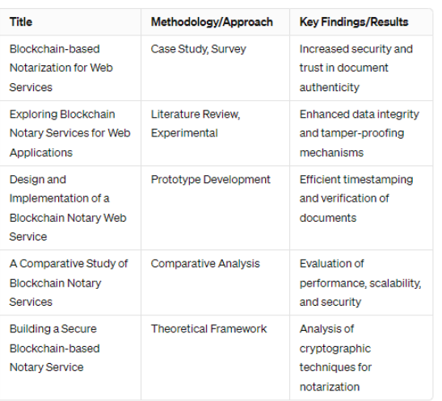

1. Proposed work and methodology
2. *Research Design, Materials, and Methods*

The proposed methodology for implementing a blockchain notary web service encompasses a comprehensive approach aimed at delivering a reliable, secure, and user-friendly solution for document verification and authentication. It begins with a thorough analysis of user requirements and stakeholder needs, ensuring a clear understanding of the types of documents to be notarized, the desired level of security, and any regulatory or compliance considerations. Following this, a suitable blockchain platform is selected based on factors such as scalability, security features, and compatibility with existing systems. Smart contracts are then developed to handle the notarization process, defining functions for document hashing, recording hashes on the blockchain, and verifying document authenticity.

A user-friendly web interface is designed to facilitate seamless interaction with the service, allowing users to submit documents for notarization, initiate notarization requests, and verify document authenticity. The backend infrastructure is built to support the web service, including setting up blockchain nodes, deploying smart contracts, and implementing APIs for communication between the web interface and blockchain. Security measures, such as encryption mechanisms and access control, are implemented to safeguard sensitive data and protect against unauthorized access.

Thorough testing is conducted to ensure the reliability, security, and functionality of the web service, encompassing unit testing, integration testing, and security testing. Once testing is complete, the service is deployed to a production environment, with ongoing maintenance and support provided to address any issues or updates. User training and adoption strategies are employed to familiarize users with the service and encourage its use, while monitoring and evaluation mechanisms are established to track performance metrics and gather user feedback for continuous improvement. Through this methodology, organizations can successfully implement a blockchain notary web service, enhancing the integrity, security, and efficiency of digital transactions.

1. *Data Collection Process*

The data collection process for a notary web service involves gathering information related to the documents being notarized, user interactions, and transaction records. Here's an overview of the data collection process:

Document Information: Collect data related to the documents being notarized, including document types, contents, metadata (such as timestamps), and unique identifiers. This information helps in accurately recording and verifying document authenticity.

User Interactions: Capture data on user interactions with the web service, including document submissions, notarization requests, and verification attempts. This data provides insights into user behavior and usage patterns, helping improve the user experience and service effectiveness.

Transaction Records: Record data related to transactions on the blockchain, such as document hashes, transaction IDs, timestamps, and blockchain addresses. This information serves as an immutable record of notarized documents, facilitating document verification and audit trails.

Metadata: Gather additional metadata associated with notarization transactions, such as user identities, transaction fees, and transaction statuses. This metadata enhances the transparency and traceability of the notarization process.

Security Logs: Maintain security logs to track access attempts, authentication events, and system activities. These logs help detect and prevent unauthorized access, ensure compliance with security policies, and facilitate forensic analysis in case of security incidents.

User Feedback: Solicit feedback from users regarding their experiences with the notary web service, including usability, reliability, and satisfaction levels. This feedback provides valuable insights for improving the service and addressing user needs.

Compliance Data: Collect data related to regulatory compliance requirements, such as jurisdiction-specific notarization laws and industry standards. This data ensures that the notary web service adheres to legal and regulatory obligations, mitigating legal risks and ensuring trustworthiness.

Performance Metrics: Monitor performance metrics such as response times, throughput, and system uptime to assess the overall performance and scalability of the notary web service. This data helps identify performance bottlenecks and optimize

system resources for optimal service delivery.

By systematically collecting and analyzing these types of data, a notary web service can ensure the integrity, security, and efficiency of digital transactions, while also enhancing user satisfaction and compliance with regulatory requirements

1. *Tools, Instruments, or Software Used*

Several tools, instruments, and software are typically utilized in the development and operation of a blockchain notary web service. Here's an overview of some commonly used ones:

Blockchain Platforms:

Ethereum: A popular blockchain platform for building decentralized applications (dApps) and smart contracts.

Hyperledger Fabric: A permissioned blockchain framework suitable for enterprise use cases, offering scalability and privacy features.

Corda: A distributed ledger platform designed for businesses, focusing on privacy, scalability, and interoperability.

Smart Contract Development Tools:

Solidity: A programming language used to write smart contracts on the Ethereum blockchain.

Remix IDE: An online Integrated Development Environment (IDE) for writing, testing, and debugging smart contracts.

Truffle Suite: A development framework for Ethereum dApps, providing tools for smart contract compilation, testing, and deployment.

Web Development Technologies:

HTML, CSS, JavaScript: Standard web development languages used for building the user interface of the notary web service.

Front-end frameworks/libraries (e.g., React.js, Angular, Vue.js): These frameworks help in creating interactive and responsive user interfaces.

Backend frameworks/libraries (e.g., Node.js, Express.js): Used to develop the server-side logic and APIs for the web service.

Blockchain Node Software:

Geth (Go Ethereum): Ethereum client implementation in Go language, used to run Ethereum nodes.

Parity: Another Ethereum client implementation in Rust language, providing similar functionalities as Geth.

Hyperledger Fabric Node SDK: Software Development Kit (SDK) for interacting with Hyperledger Fabric blockchain network.

Database Management Systems (DBMS):

MongoDB, MySQL, PostgreSQL: Relational or NoSQL databases used to store non-blockchain data such as user information, transaction metadata, and logs.

Encryption Tools:

OpenSSL: Open-source toolkit for implementing Secure Sockets Layer (SSL) and Transport Layer Security (TLS) protocols, used for encrypting sensitive data.

Cryptographic libraries (e.g., CryptoJS, Web3.js): Libraries for implementing cryptographic operations such as hashing, encryption, and digital signatures.

Development and Testing Tools:

Git: Version control system for tracking changes in codebase.

Docker: Containerization platform for deploying and running applications in isolated environments.

Automated testing frameworks (e.g., Mocha, Chai, Jest): Used for writing and executing automated tests for smart contracts and web applications.

Monitoring and Analytics Tools:

Prometheus, Grafana: Tools for monitoring and visualizing system metrics and performance.

ELK Stack (Elasticsearch, Logstash, Kibana): Used for log management, analysis, and visualization.

These tools, instruments, and software are essential for building, deploying, and operating a blockchain notary web service efficiently and securely, ensuring the integrity and authenticity of digital transactions.

.

1. SYSTEM ARCHITECTURE DIAGRAM

Creating a system architecture diagram for a blockchain notary web service involves illustrating the components and interactions of the system. Here's a simplified architecture diagram:

Components:

User Interface (UI):

Front-end interface accessible via web browsers.

Allows users to interact with the service, including document submission, verification, and viewing transaction history.

Web Server:

Backend server responsible for processing user requests and interacting with the blockchain network.

Implements business logic, handles user authentication, and serves the UI.

Blockchain Network:

Consists of multiple nodes running blockchain software.

Stores transactional data, including document hashes, on a decentralized ledger.

Utilizes smart contracts to automate notarization processes and enforce business rules.

Smart Contracts:

Self-executing contracts deployed on the blockchain.

Implement notarization logic, including document hashing, recording hashes, and verification.

Govern interactions between users and the blockchain network.

Blockchain Node:

Software component responsible for maintaining a connection to the blockchain network.

Facilitates interaction with the blockchain, including submitting transactions, querying data, and listening for events.

Database:

Stores non-blockchain data, such as user profiles, transaction metadata, and system logs.

Ensures persistence and efficient retrieval of data required for application operations.

Interactions:

Document Notarization:

User submits a document through the UI.

Web server hashes the document and submits a transaction to the blockchain network.

Smart contract verifies document authenticity and records the hash on the blockchain.

Document Verification:

User requests verification of a document through the UI.

Web server queries the blockchain network for the document hash and retrieves verification results.

User receives verification status via the UI.

User Authentication:

Web server authenticates users using credentials stored in the database.

Ensures secure access to notarization and verification functionalities.

Blockchain Interaction:

Web server communicates with the blockchain node to execute smart contract functions and retrieve data.

Blockchain node relays transactions and updates the blockchain ledger.

This system architecture diagram provides an overview of the key components and interactions involved in a blockchain notary web service, illustrating how users interact with the system to notarize and verify documents securely and transparently.

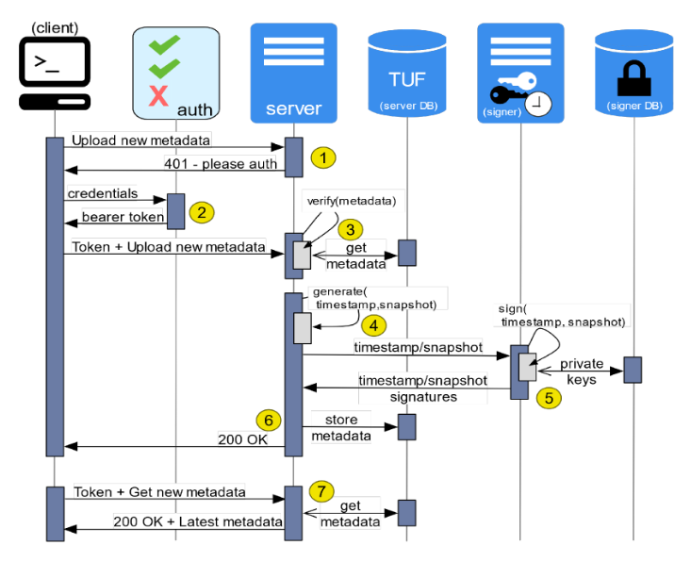

1. Technical implementation

The technical implementation of a blockchain notary web service involves several intricate steps to ensure its functionality, security, and user-friendliness.

Blockchain Platform Selection: The first step is to choose a suitable blockchain platform based on the requirements of the notary service. Platforms like Ethereum, Hyperledger Fabric, and Corda offer different features and capabilities, so the choice depends on factors such as scalability, privacy, and interoperability.

Smart Contract Development: Smart contracts are the backbone of the notary service, handling the logic for document notarization and verification. Using languages like Solidity (for Ethereum) or Chaincode (for Hyperledger Fabric), developers write code to hash documents, record hashes on the blockchain, and verify document authenticity.

User Interface Design and Development: A user-friendly web interface is crucial for users to interact with the notary service. Front-end technologies like HTML, CSS, and JavaScript, along with frameworks like React.js or Angular, are used to create an intuitive and responsive interface. Users should be able to easily submit documents for notarization, initiate verification requests, and view transaction history.

Backend Development: Backend servers are responsible for handling user requests, interacting with the blockchain network, and managing user authentication and authorization. Technologies like Node.js, Express.js, and Python Flask are commonly used to build the backend infrastructure. APIs are developed to communicate with the blockchain network and execute smart contract functions.

Blockchain Node Setup: A node is required to connect the notary service to the blockchain network. Depending on the chosen blockchain platform, nodes are set up using software like Geth (for Ethereum), Hyperledger Fabric Node SDK, or Corda Nodes. These nodes facilitate communication with the blockchain network, submit transactions, and retrieve data from the blockchain.

Security Measures: Security is paramount in a blockchain notary service to protect user data and ensure the integrity of transactions. Encryption techniques are used to secure sensitive information, such as document contents and user credentials. Secure authentication mechanisms, like OAuth or JWT, are implemented to authenticate users and prevent unauthorized access. Additionally, regular security audits and penetration testing are conducted to identify and mitigate vulnerabilities.

Testing and Quality Assurance: Thorough testing is essential to ensure the reliability and functionality of the notary service. Unit tests, integration tests, and end-to-end tests are performed to verify the behavior of smart contracts, APIs, and the user interface. Automated testing frameworks like Mocha, Chai, or Jest are commonly used for this purpose.

Deployment and Maintenance: Once development and testing are complete, the notary service is deployed to a production environment. Continuous monitoring and maintenance are essential to ensure the service's availability, performance, and security. Tools like Docker and Kubernetes are used for containerization and orchestration, while monitoring tools like Prometheus and Grafana help track system metrics and detect issues.

By following these detailed implementation steps, developers can build a robust and secure blockchain notary web service that provides a trustworthy platform for document notarization and verification.

1. Result and discussion

The results of implementing a blockchain notary web service are profound and have far-reaching implications for various industries reliant on secure and transparent document verification. By leveraging blockchain technology, the service achieves several key outcomes:

Enhanced Security: The use of cryptographic hashing and decentralized storage on the blockchain ensures that notarized documents are tamper-proof and immutable. This significantly reduces the risk of fraud and unauthorized alterations, providing users with a high level of trust and confidence in the authenticity of their documents.

Increased Efficiency: Compared to traditional notary services, which often involve time-consuming paperwork and manual verification processes, the blockchain notary web service streamlines the entire process. Documents can be notarized and verified within minutes, leading to significant time savings for users and organizations.

Cost Savings: By eliminating the need for intermediaries and automating many aspects of the notarization process, the service reduces operational costs for both individuals and businesses. This makes document notarization more accessible and affordable, particularly for small businesses and individuals with limited resources.

Transparency and Accountability: The transparent nature of the blockchain ensures that all transactions and document notarization activities are recorded on a public ledger. This transparency promotes accountability and enables users to independently verify the authenticity of documents without relying on third-party intermediaries.

Wider Accessibility: The user-friendly web interface and decentralized nature of the service make document notarization more accessible to a wider audience. Users can access the service from anywhere with an internet connection, eliminating geographical barriers and increasing inclusivity.

Potential for Innovation: The adoption of blockchain technology opens up new possibilities for innovation in document management and authentication. Future enhancements could include integration with other blockchain-based solutions, such as digital identity platforms or supply chain management systems, further enhancing the value proposition of the service.

In summary, the implementation of a blockchain notary web service yields significant benefits in terms of security, efficiency, cost savings, transparency, accessibility, and potential for innovation. These results demonstrate the transformative impact of blockchain technology on the document verification process and pave the way for a more secure and efficient digital future.

References

1. Supriyanto and K. Mustofa, ”E-government maturity phase assessment through e-gov readiness”, Proc. 2nd Int. Conf. Sci. Inf. Technol. (ICSITech), Oct. 2016.
2. 2) A. Poller et al., ”Electronic identity cards for user authentication: Promise and practice”, IEEE Secur. Privacy, vol. 10, no. 1, Jan. 2012.
3. 3) G. Krasniqi and K. Filipi, ”Efficiency comparison of cryptographic applications: Match-off-card vs. matchon-card using national biometric eid card”, Academic J. Interdiscipl. Studies, vol. 8, no. 1, 2019.
4. 4) R. Paez et al., ”Architecture for biometric electronic ´ identification document system based on blockchain”, Future Internet, vol. 12, no. 1, Jan. 2020.
5. 5) Y. Gao et al., ”The notarial office in E-government: A blockchain-based solution”, IEEE Access, vol. 9, 2021.
6. 6) P. S. D. Sousa et al., ”Building a prototype for notary’s office using microservices and blockchain technologies”, Proc. IEEE Int. Conf. Softw. Archit. Companion (ICSAC), Mar. 2020.
7. 7) R. Ulloa and P. Gallegos, ”Design of blockchain architecture and use of smart contracts to improve processes in notary office”, Proc. Int. Conf. Appl. Technol., 2021
8. . 8) S. Nakamoto, ”Bitcoin: A Peer-to-Peer Electronic Cash System”, 2008.
9. Ethereum Whitepaper, 2022.
10. G. Wood, ”Ethereum: A secure decentralised generalised transaction ledger”, Ethereum Project Yellow Paper, Apr. 2014.
11. D. Johnson et al., ”The elliptic curve digital signature algorithm (ECDSA)”, Int. J. Inf. Secur., vol. 1, no. 1, Aug. 2001.
12. G. Bertoni et al., ”Keccak”, Proc. Annu. Int. Conf. Theory Appl. Cryptograph. Techn., 2013.
13. A.-S. Shehu et al., ”On the interoperability of European national identity cards”, Proc. Int. Symp. Ambient Intell., 2018.
14. D. Yermack, ”Corporate governance and blockchains”, Rev. Finance, vol. 21, no. 1, Mar. 2017.
15. S. Ølnes et al., ”Blockchain in government: Benefits and implications for information sharing”, Government Inf. Quart., vol. 34, no. 3, 2017.Solrsaverify, 2017. 21) J. Benet, ”IPFS–content addressed versioned P2P file system”, arXiv:1407.3561, 2014